Guide for FAST Linearization of the 5-MW Reference Wind Turbine:

Control focused

A general turbine linear model can be described by:

$$\left\{\begin{aligned}Δ\dot{x}=A Δx+BΔu+B_{d}Δu_{d} \\ Δy=CΔx+DΔu+D_{d}Δu_{d}\end{aligned}\right.$$

Where,

$Δx$ is the state vector;

$Δu$ is the control input vector;

$Δu_{d}$ is the disturbance input vector;

$Δy$ is the control (or measured) output;

$A$ represents the state matrix;

$B$ the control input gain matrix;

$B_{d}$ is the disturbance input gain matrix;

$C$ relates the measured output $Δy$ to the turbine states;

$D$ relates the control input to the output;

$D_{d}$ relates the measured output to the disturbance states.

In this notation, $Δ\dot{x}$ represents the time derivative of $Δx$.

That being said, we focus on how to acquire these matrices.

First, you will need to download the FAST v7.02.00d-bjj (at least was the one indicated on the NREL forum and the one I used), you can download it here: <https://nwtc.nrel.gov/FAST7> or, in my repository here: <https://github.com/borgestassio/FASTv7>. In addition, you will need the model for the 5MW Wind Turbine, available on <http://wind.nrel.gov/public/jjonkman/NRELOffshrBsline5MW>, and on my repository listed above as well.

**Note: When time I wrote this guide, FAST V8 did not have the option to linearize the turbine model, so, if things changed, please follow the proper guide to perform the linearization.**

For the linearization, the process will follow the instructions presented in [1], despite its use of a 2 bladed turbine, the process is almost the same, and for the parameters regarding the 5 MW Wind Turbine, we’ll follow [2], where contains all definitions and configurations of the turbine.

Inside your .fst file, in this case, “NRELOffshrBsline5MW_Onshore.fst”, go to the **FEATURE FLAGS** (LINE 54). Now we begin to modify the configuration file to obtain the results needed, the appropriated Degrees of Freedom (DOF) will be used for the linearization:

* FlapDOF1;
* DrTrDOF;
* GenDOF;
* CompAero.

The others DOFs must be set to False, so your file will look like this:

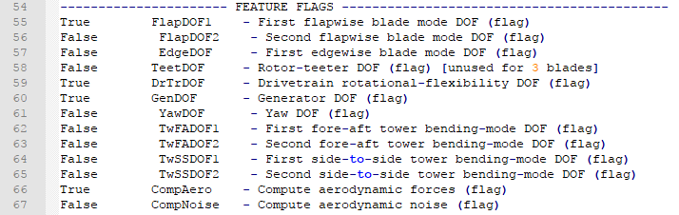

Figure 1 Degrees of Freedom (DOFs) configuration for linearization

To perform the simulation, we will need to change some lines in the **SIMULATION CONTROL** part:

* ADAMSPREP should be set to 1 (Run FAST);
* AnalMode should be 2 (which is to create a periodic linearized model);
* NumBl remains the same, as we’re working with 3 blades;
* TMax is advised to be 1200, although the linearization will be achieved before that;
* DT is set to 0.006 for no particular reason described in any document.

The **SIMULATION CONTROL** portion of your file should be:

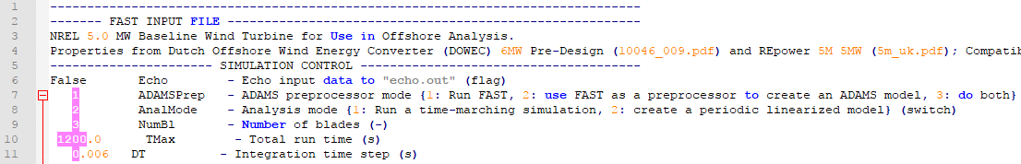

Figure 2 Simulation Control configurations for linearization

The linearization process utilizes the turbine parameters to perform the calculations, so, in order to successful linearize the model, we must pass to FAST the correct parameters to the turbine control, which is done in the **TURINE CONTROL** portion:

* YCMode must be 0;
* PCMode is set to 0 as well;
* VSContrl is activated, set to 1;
* VS_RtGnSp must be 121.6805;
* VS_RtTq is

# Referências

|  |  |
| --- | --- |
| [1] | S. B. W. M. a. G. S. J. Jonkman, “Definition of a 5-MW Reference Wind Turbine for Offshore System Development,” National Renewable Energy Laboratory, Golden, Colorado, USA, 2009. |
| [2] | A. W. a. L. Fingersh, *Advanced Control Design for Wind Turbines; Part I: Control Design, Implementation, and Initial Tests,* Golden, Colorado: National Renewable Energy Laboratory, 2008. |
| [3] | B. J. a. J. Jonkman, *FAST v8.16.00a-bjj,* Golde, Colorado, USA: NREL, 2016. |